**Ideation Phase**

**Define the Problem Statements**

|  |  |
| --- | --- |
| Date | 06 May 2023 |
| Team ID | NM2023TMID14700 |
| Project Name | Drowsiness and alerting system |
| Maximum Marks | 2 Marks |

**Customer Problem Statement Template:**

Create a problem statement to understand your customer's point of view. The Customer Problem Statement template helps you focus on what matters to create experiences people will love.

A well-articulated customer problem statement allows you and your team to find the ideal solution for the challenges your customers face. Throughout the process, you’ll also be able to empathize with your customers, which helps you better understand how they perceive your product or service.

Reference: <https://miro.com/templates/customer-problem-statement/>

**Example:**

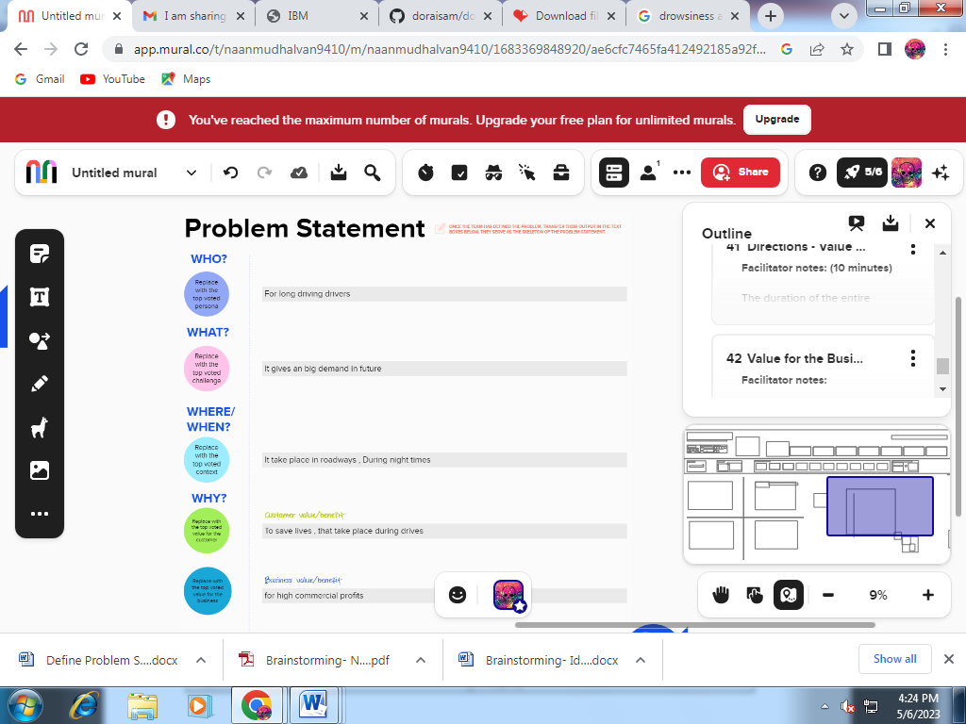

|  |  |  |  |  |  |
| --- | --- | --- | --- | --- | --- |
| **Problem Statement (PS)** | **I am (Customer)** | **I’m trying to** | **But** | **Because** | **Which makes me feel** |
| PS-1 | Good quality | Reduce accidents during night times | Accidents take place | Due to drowsiness | It saves many people lives by preventing from accidents |
| PS-2 | Long lasting | Save lives of drivers , who drives | Loss of lives | Due to accidents | Population increases due reduction of accidents |